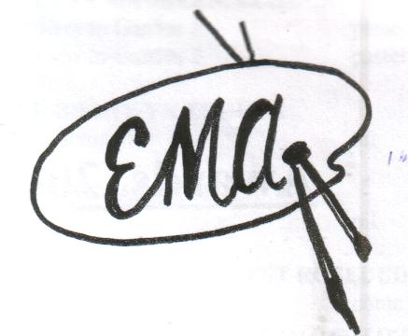
ECHUCA MOAMA ARTISTS INC

Alton Gallery
PO. Box 339 or 111 Hare Street. ECHUCA. 3564
Phone (03) 5480 2160
Open to the public:
Friday 10-3 and Saturdays 10-1
(Other times by appointment]
Phone: 0439 460 690

MONTHLY ACTIVITIES
1st Thursday of the month (except January) General Meeting 1pm
Friday each week Artists in residence 10-3

MEMBERSHIP APPLICATION $25 per annum
January till December each year

I, ………………………………………………………………………………………………………………………………………………..

Address ……………………………………………………………………………………………………………………………………..

Phone ………………………………………………………………………… Mobile …………………………………………………

Email address …………………………………………………………………………………………………………………………….

D.O.B ………………………………………………………………………………

wish to become a member of the Echuca Moama Artists Inc. I will support the purposes and agree to comply with the Rules of the Association.

I can help on the Gallery Roster Saturday 10-1 YES NO (please circle)

I enclose cash/cheque [please circle] = $25-00

Bank Details: Echuca Moama Artists Inc
BSB 063511
Acc No 1005 3941

